WhatABook

TECHNICAL DESIGN DOCUMENT

|  |  |
| --- | --- |
| **Authors** | TiaNiecia Mosley Butler & William Austin |
| **Last Updated** | 07/12/2023 8:40pm Eastern |
| **Version Number** | 1.4 |

**Version History**

| Name | Date | Reason for Change | Version |
| --- | --- | --- | --- |
| Austin, William | 07/05/2023 | Creation of Document | 1.0 |
| Butler, TiaNiecia | 07/07/2023 | Additions and Edits | 1.1 |
| Austin, William | 07/09/2023 | Additions and Edits | 1.2 |
| Butler, TiaNiecia | 07/09/2023 | Additions and Edits | 1.3 |
| Austin, William | 07/12/2023 | Adding ORD and NoSQL Data Structures | 1.4 |

**SECTION 1 : THE TEAM**

We are the Odyssey Development Group and we strive to take any business, large or small, on an epic journey to a powerful and effective web presence. We chose the name in reference to the Homeric Epic poem about a 10 year journey home from war. Building a web site isn’t easy. It takes time, care, and a lot of collaboration. Helmed by our esteemed captain, TiaNiecia Butler Mosley, we hope our name gives you the sense that we are in it for the long haul. We focus on the customer’s needs, and develop a long-lasting, cooperative arrangement, where the customer’s input is not only welcome, but needed. We chose the owl to represent us because of its close ties with depth of knowledge. We may be new developers, but we have deep understanding of our customers needs, and the state of the market as a whole. Our owl buddy, Pisco, guides us through every step of our web development journey with you, instilling us with a passion for knowledge about what makes your business unique and how to sell it in this incredibly competitive marketplace. Here at Odyssey we invite you to “Journey with Us”.



# SECTION 2: INTRODUCTION

Purpose

WhatABook wants to increase it’s presence online and to develop an app customers can install on their computers where customers can browse the entire stock of books of WhatABook and create personalized Wishlists of books they want to read. WhatABook also wants to allow users to search by Genre, Book Title, Author, or BookID. The hope is to get users to search for books with ease and to keep books in mind by having a wishlist to go back to when the time to buy comes around.

Goals of the Site

1. Allow customers to Browse the full stock of books at WhatABook
2. Allow customers to create wishlists and add or delete books from that wishlist
3. Allow customers to view their wishlist by entering their customerID
4. Allow customers to select a genre and see all the books within that genre
5. Allow customers to enter an Author’s name and see all the books by that author
6. Allow customers to enter a book title and see if it’s in the collection
7. Allow customers to enter a bookID and see if it’s in the collection

Core Users of the Site

1. The Avid Readers - These are users with limited computer experience, more than likely middle aged adult, who love reading, and are always looking for the next book.
2. Specialized Readers - These are the hobbyists and specialized readers. Looking to learn a new skill or read books on a specific topic.
3. Authors - Who want to make sure there books are available and findable on the site.
4. The Owner - They wants to be able to add books to the site, see what’s selling and what’s sitting around, know where in the store a book is located.
5. The Worker - They want know where to find things in the store and confirm whether or not a book is available. Less access than the owner, but more than the customer.

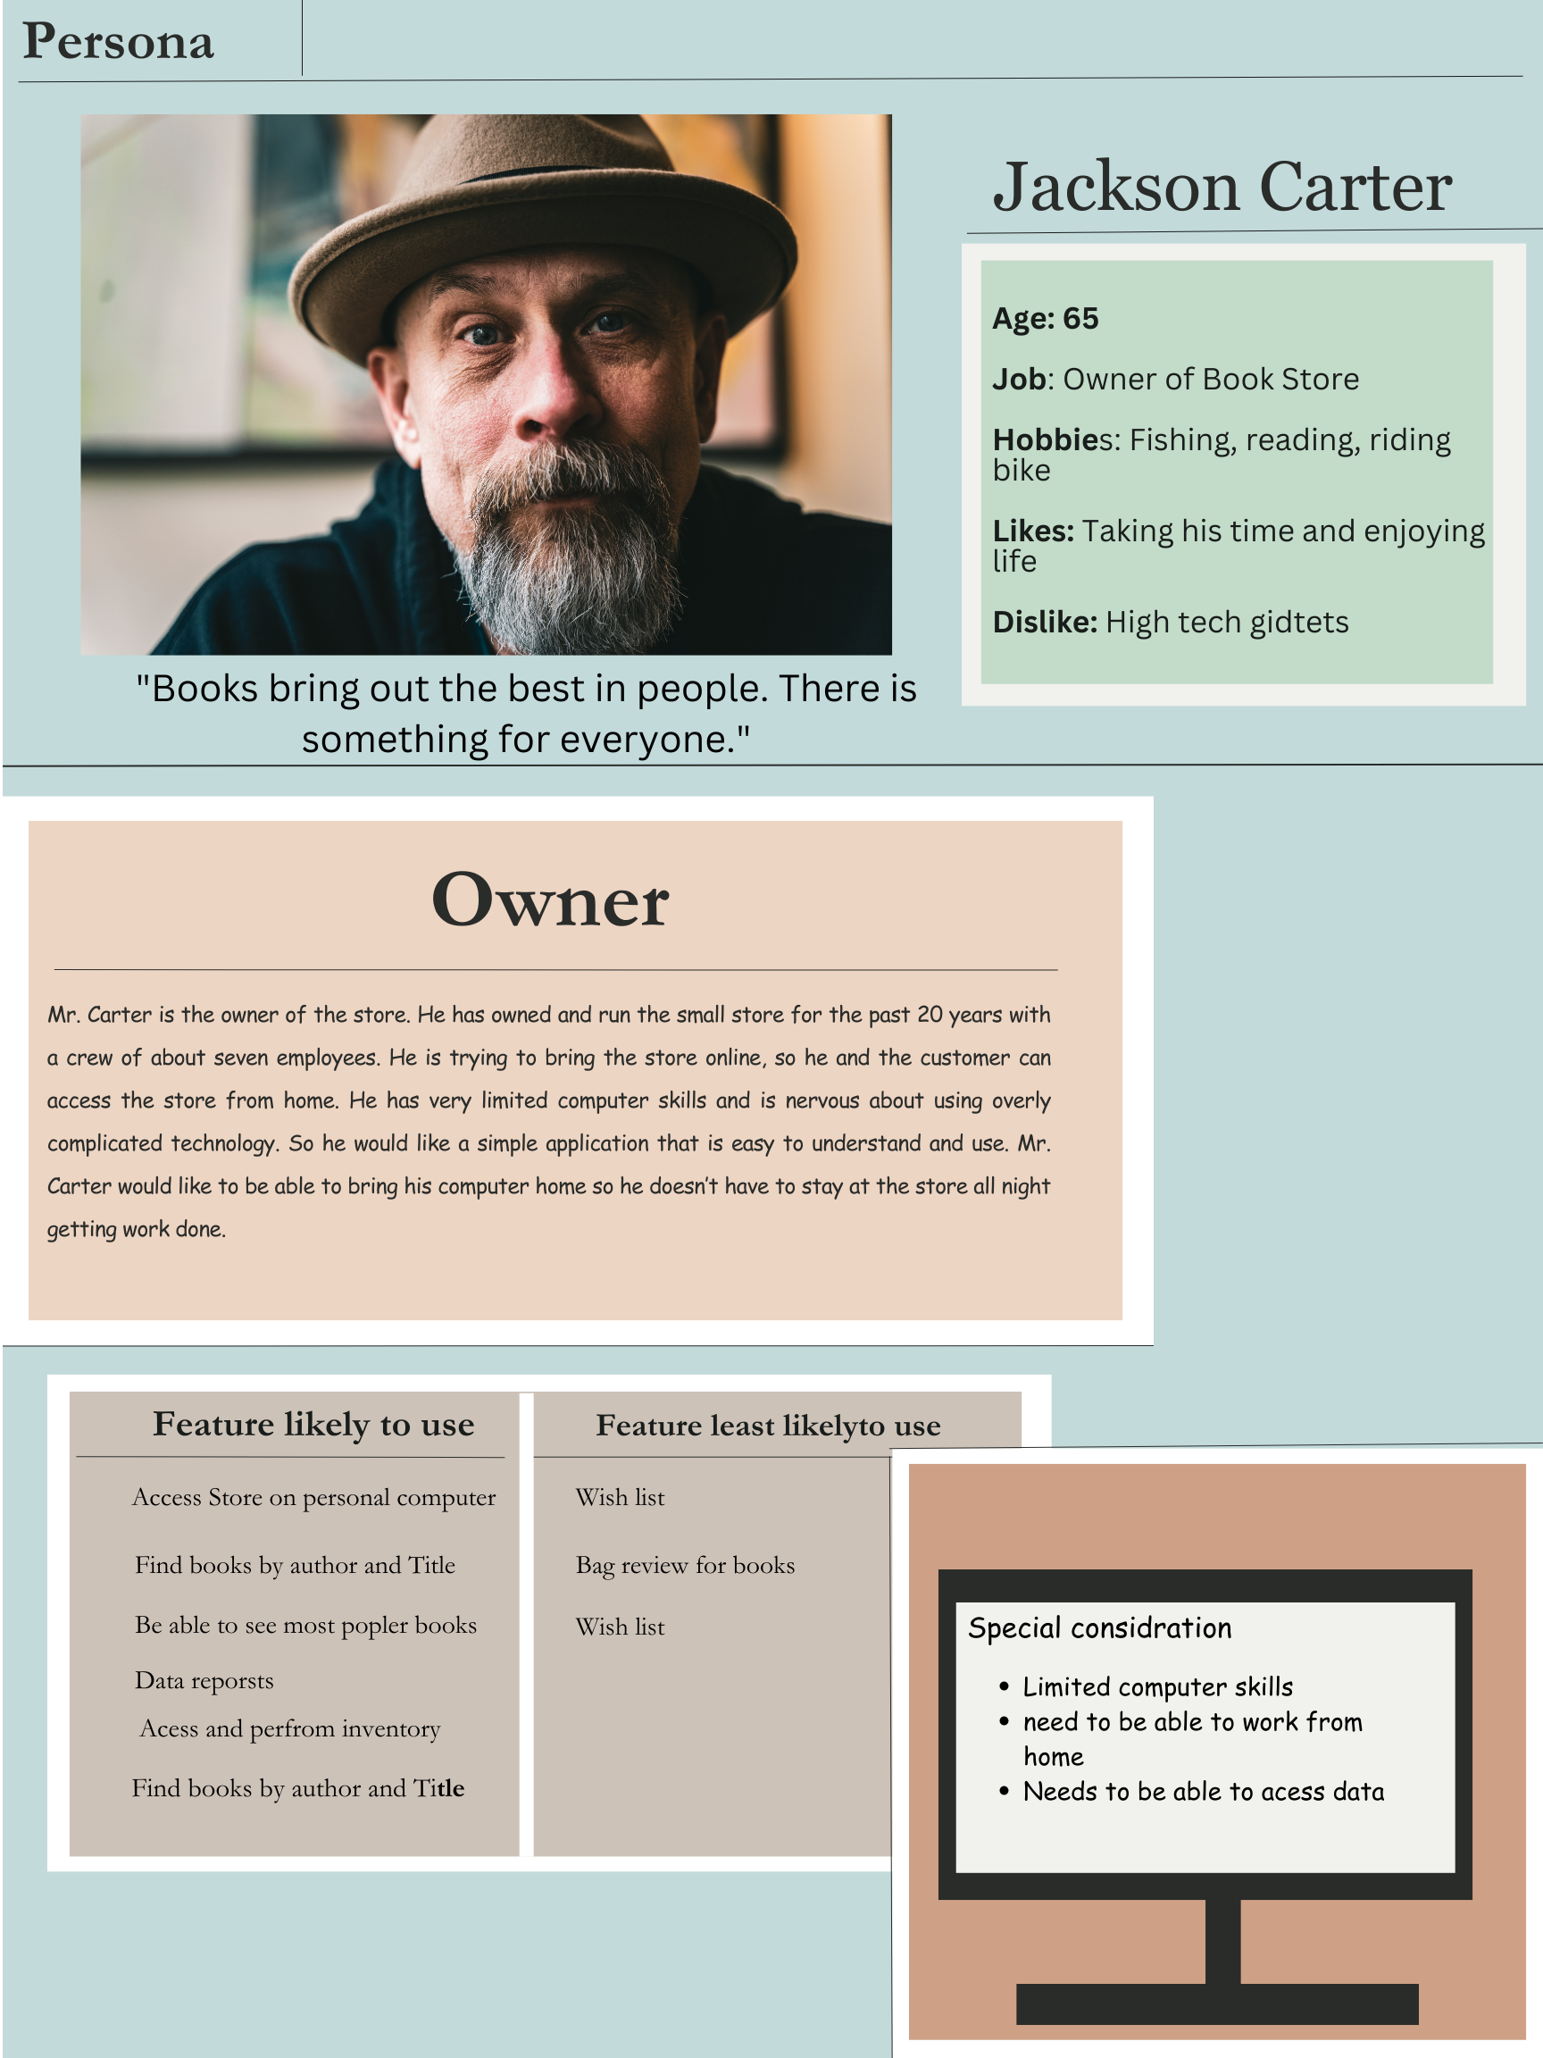

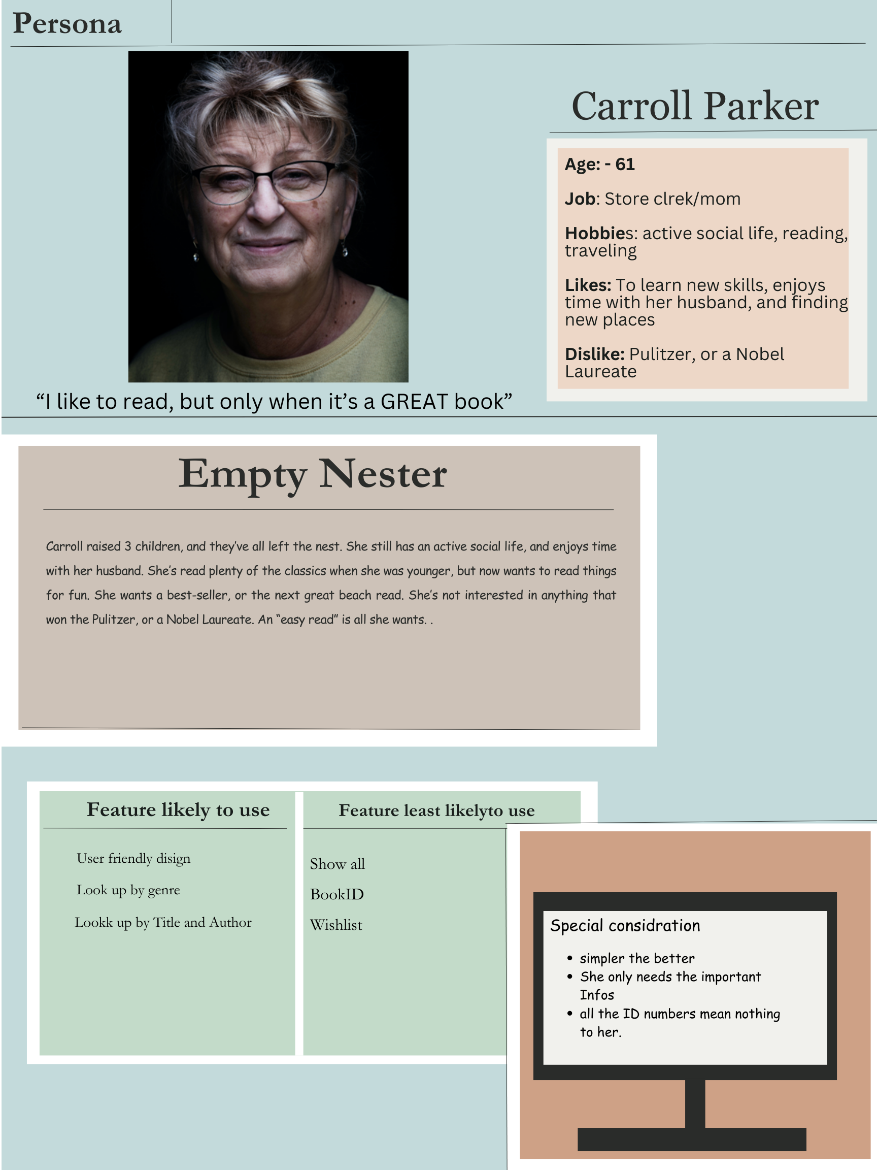

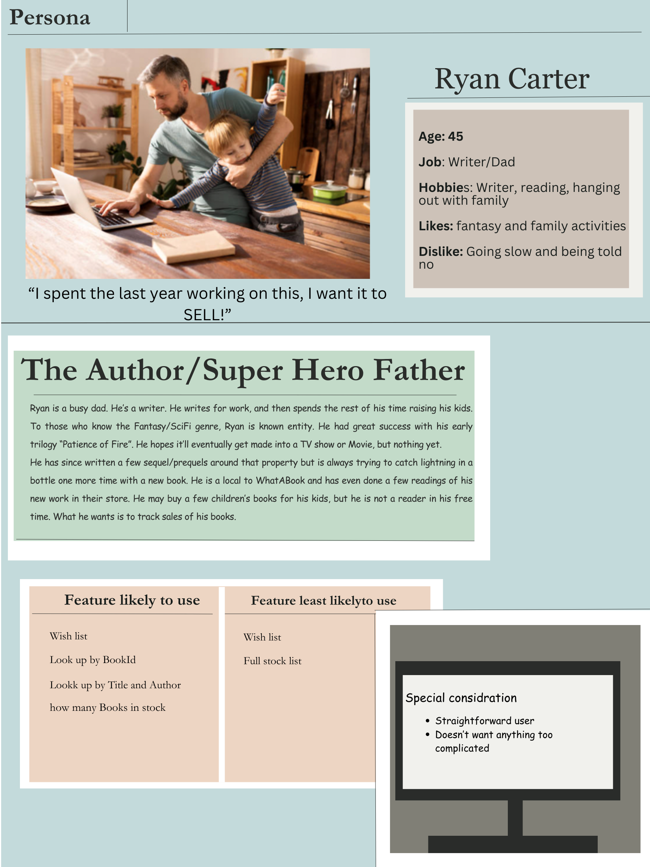

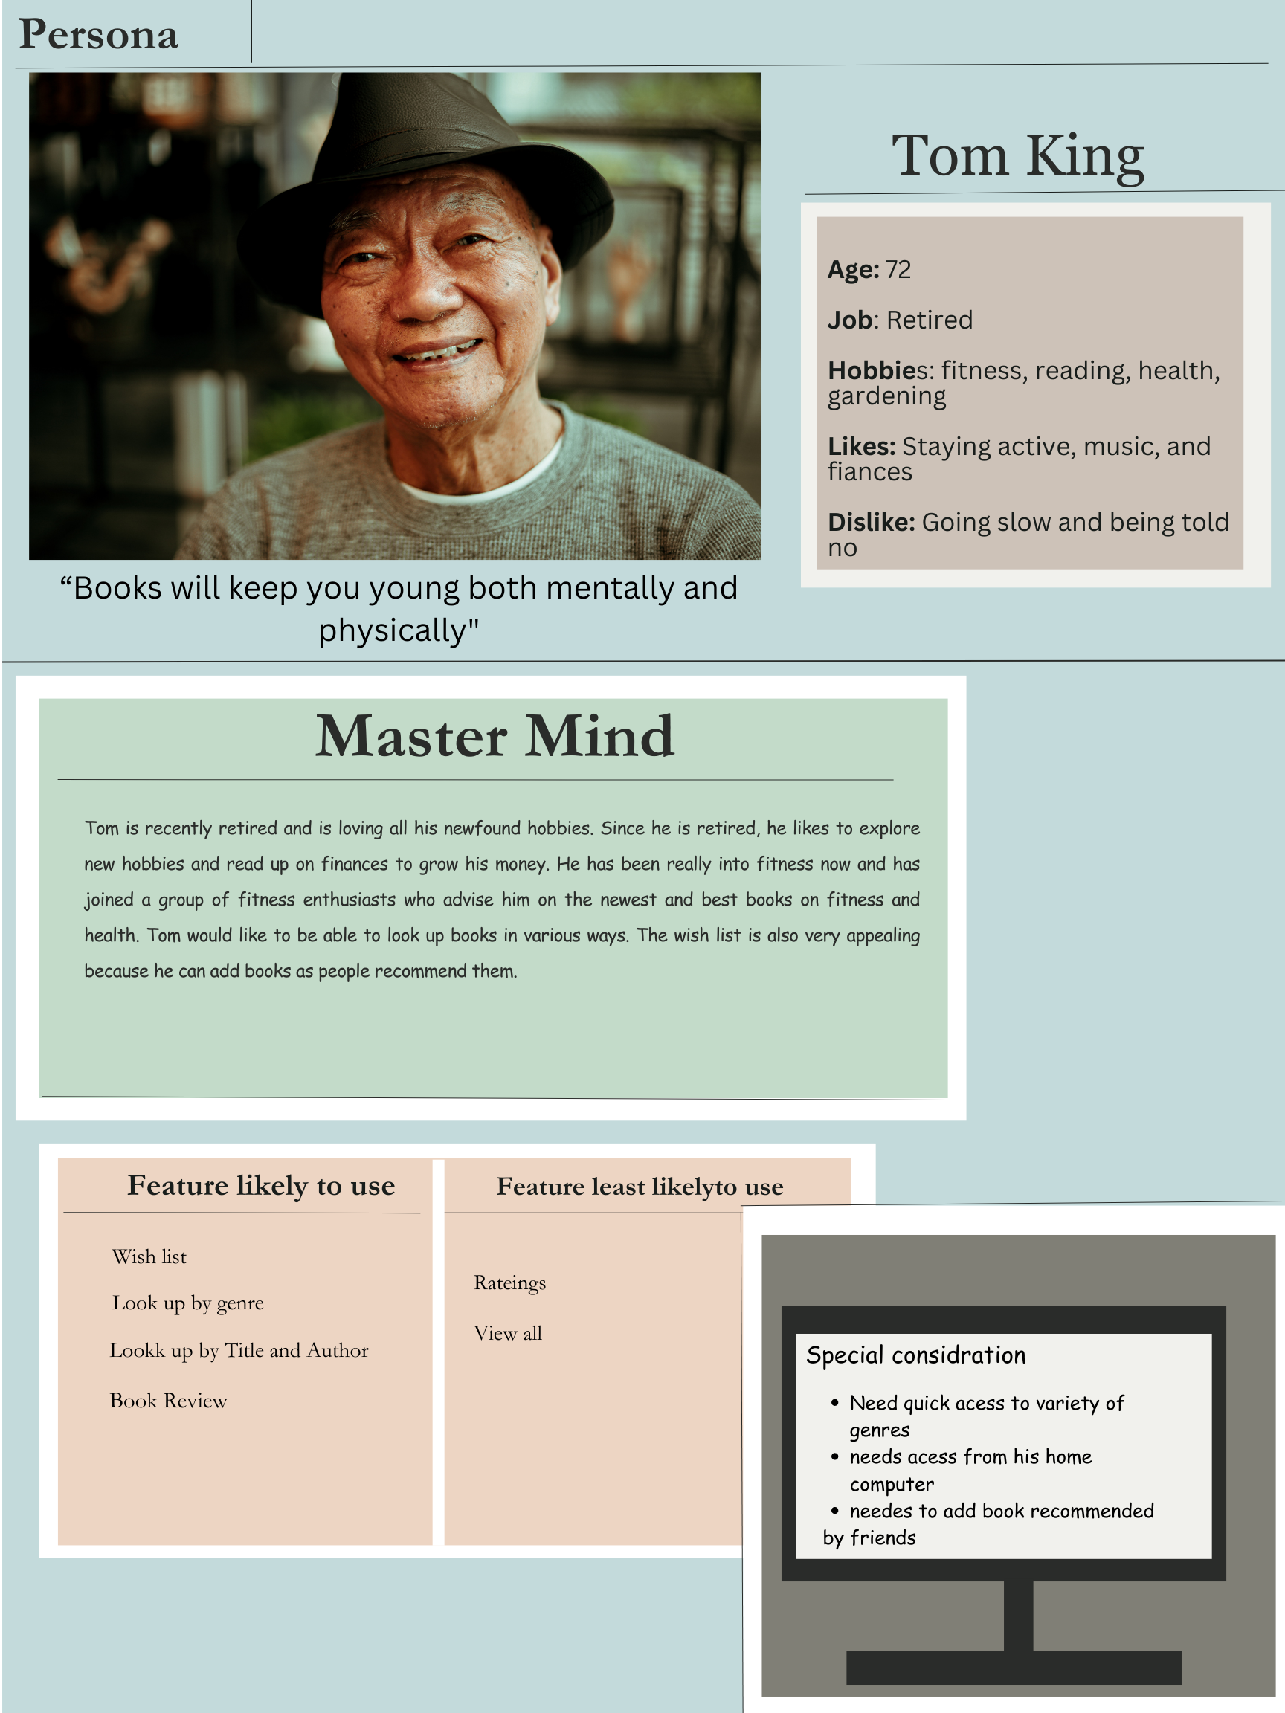

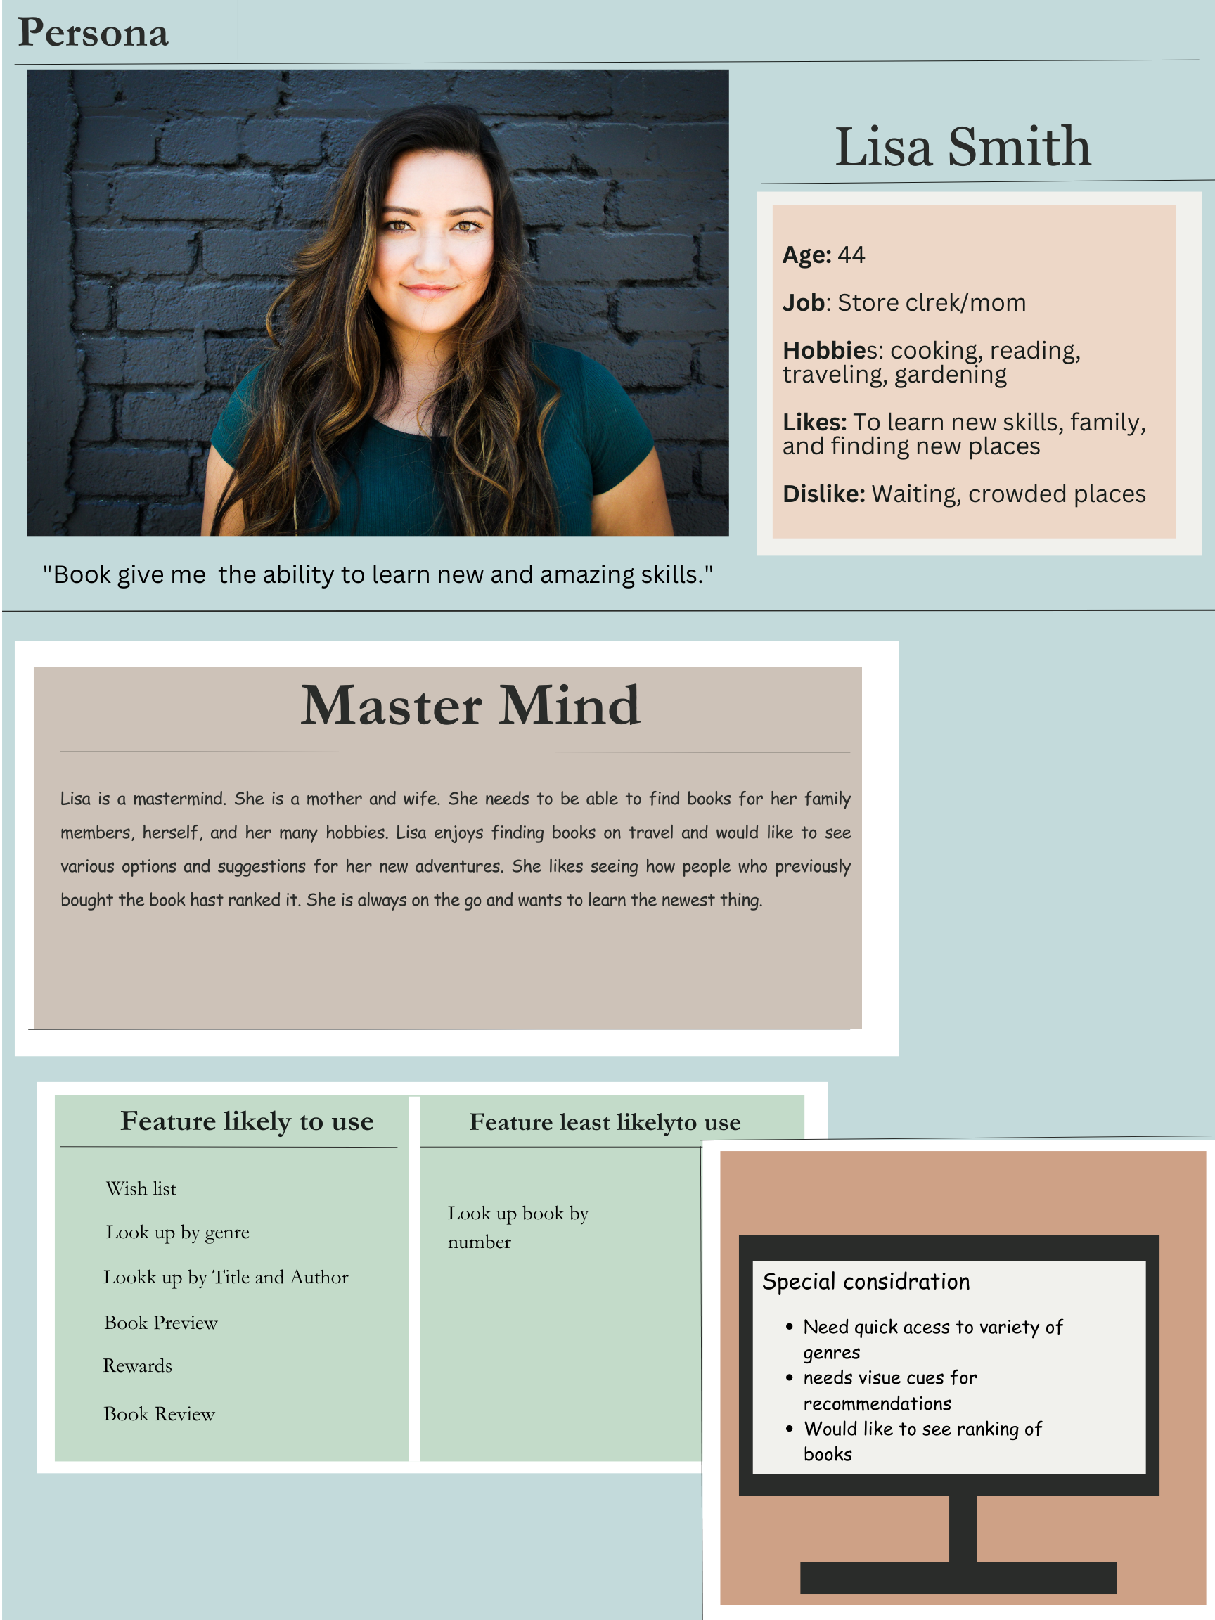

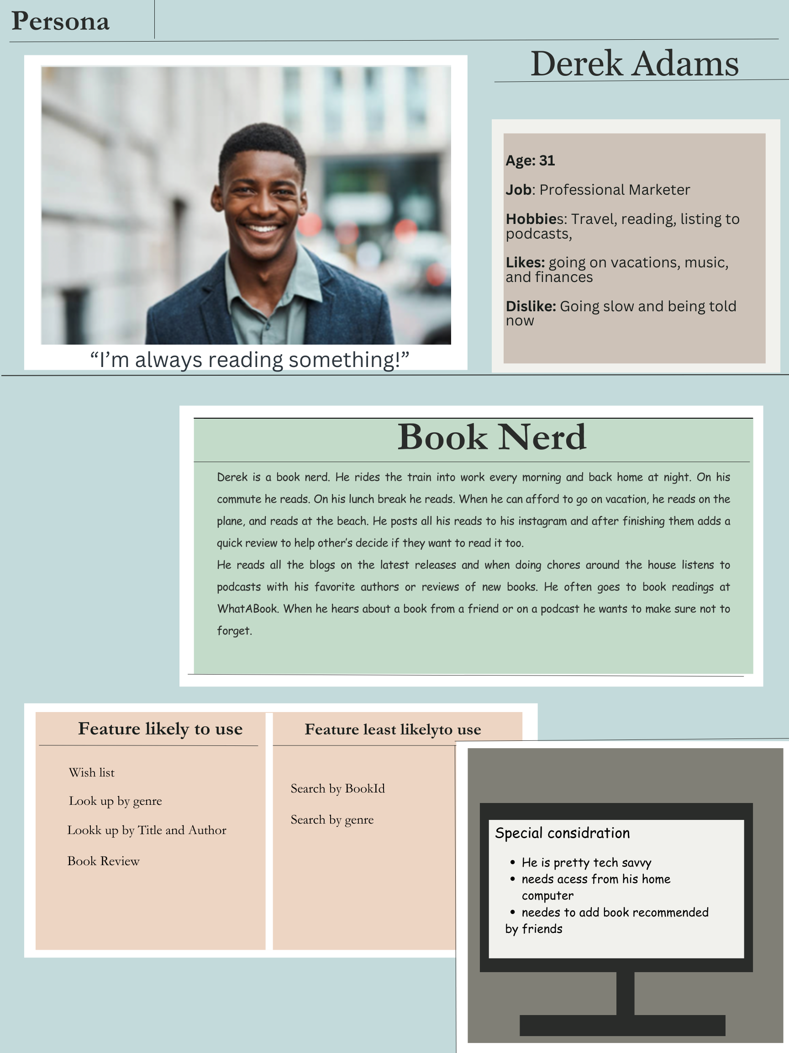

**USER STORIES**

DEREK

| STORY | STORY POINTS |
| --- | --- |
| As a customer I want to create a wishlist so that I never forget a book I want to read | 3 |
| As a customer I want to search WhatABook for a specific book title to see if they have it | 1 |
| As a customer I want to browse the entire stock of WhatABook to see if something catches my eye | 1 |
| As a customer I want to be able to delete items from my wishlist once I’ve read them so I know what I’ve read and what I still have to read | 1 |
| As a customer I want to view my wishlist to see all the books I’ve yet to read | 1 |

CARROLL

| STORY | STORY POINTS |
| --- | --- |
| As a customer I want to be able to select a genre I like and see all the books WhatABook has in that genre | 1 |
| As a customer I want to search WhatABook for a specific author and see all the books by that author. | 1 |
| As a customer I want to search for Key Words within a Title to find a specific book where I can’t remember the whole title | 5 |
| As a customer I want to be able to search multiple things at once, so an author and a genre, so I can get broad and then narrow down my options | 3 |
| As a customer I want to know if a book is available in store | 3 |

RYAN

| STORY | STORY POINTS |
| --- | --- |
| As an author I want to search for a book by Title to see if WhatABook carries my book. | 1 |
| As an author I want to search for an Author and see all the books WhatABook carries by that author (AKA Me). | 1 |
| As an author I want to search for a book by ID to see if that book is in stock and how many copies are left | 1 |
| As a customer I want to search by genre to buy the occasional children’s book for my kids | 1 |
| As a customer I want to add all my books to my wishlist to show that people want to read them. | 3 |

# SECTION 3: PROCESS DESIGN

Here is a link to the prototype we’ve created to give you some of ou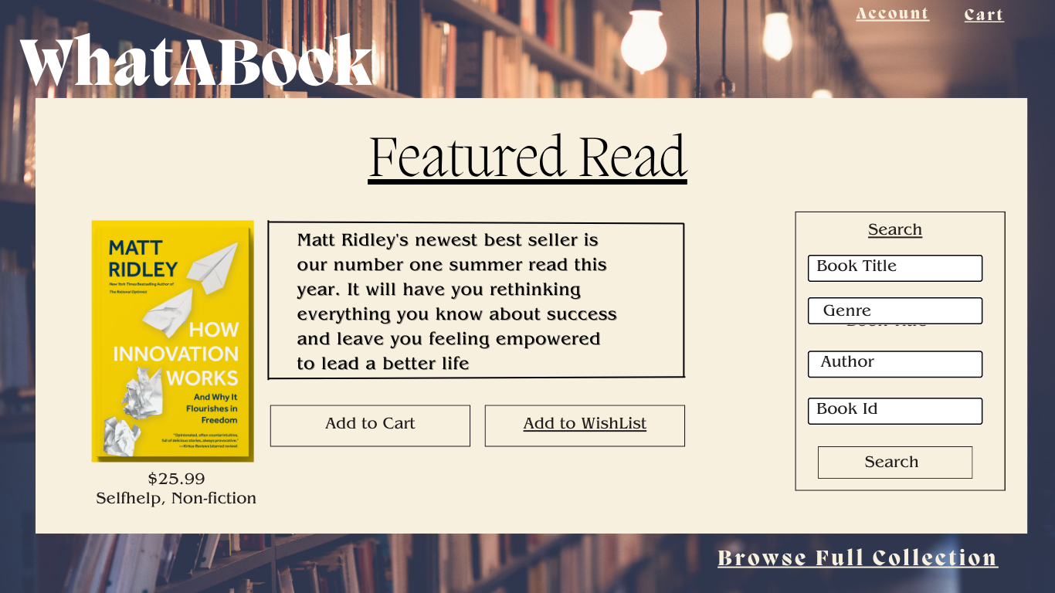r initial thoughts.

[Click Here for Prototype](https://www.canva.com/design/DAFoJamwCgA/ToZ8wbKs2Jd0dsuronDkbg/view?utm_content=DAFoJamwCgA&utm_campaign=designshare&utm_medium=link&utm_source=publishsharelink)

Here are some still images of what we’re thinking

LANDING

ENTRY PAGE

ACCOUNT SIGNIN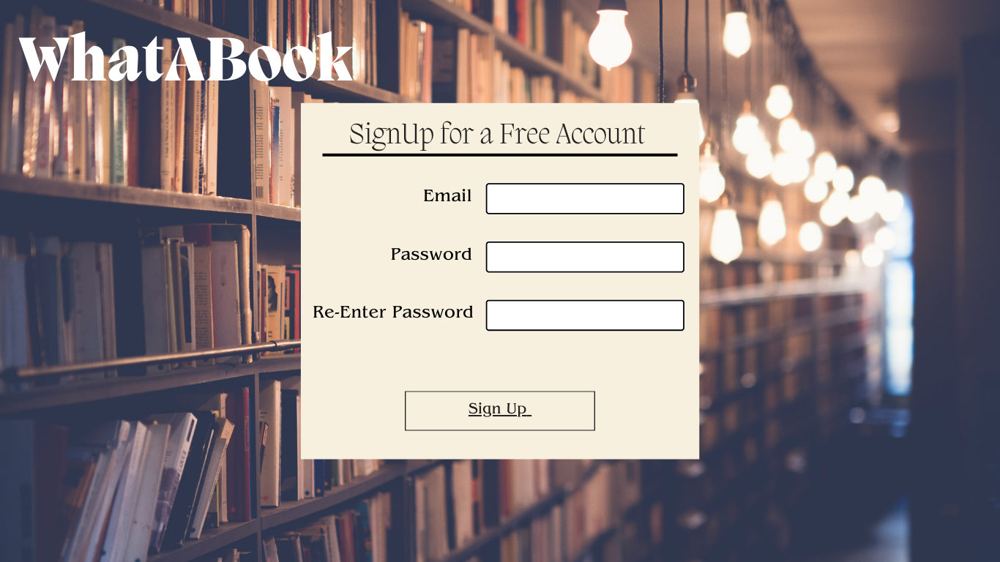

ACCOUNT SIGNUP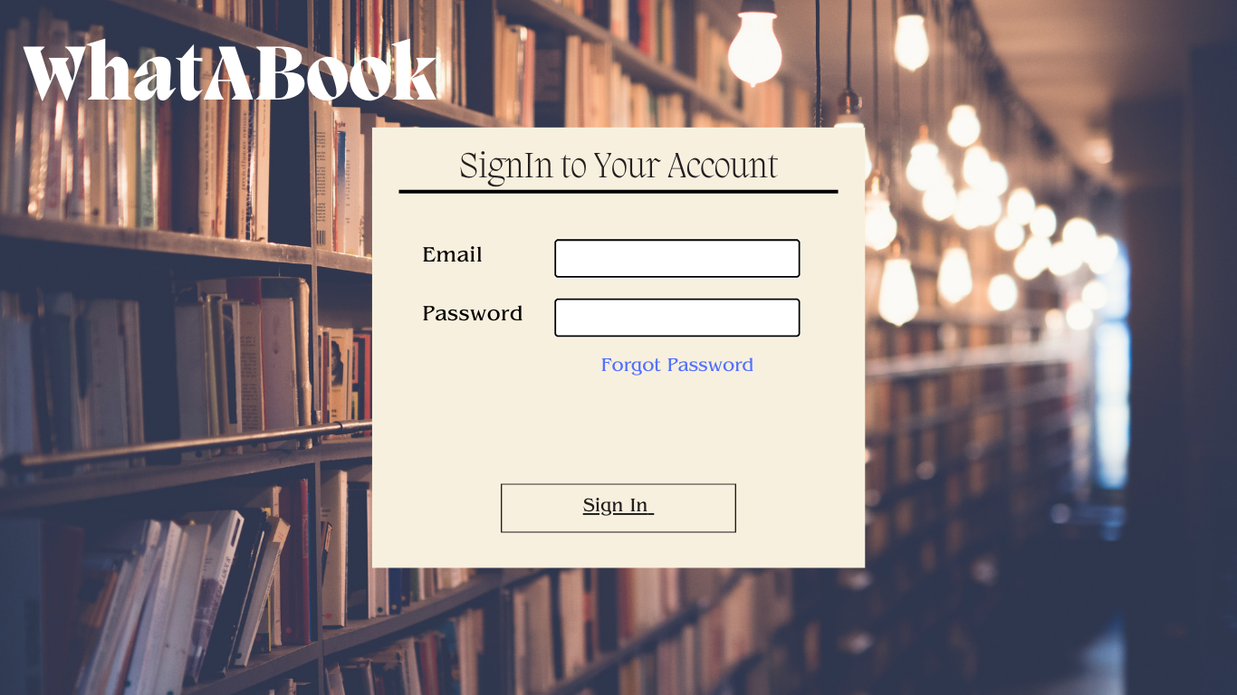

FULL COLLECTION

WISHLIST

SEARCH RESULTS BY AUTHOR



SEARCH RESULTS BY ID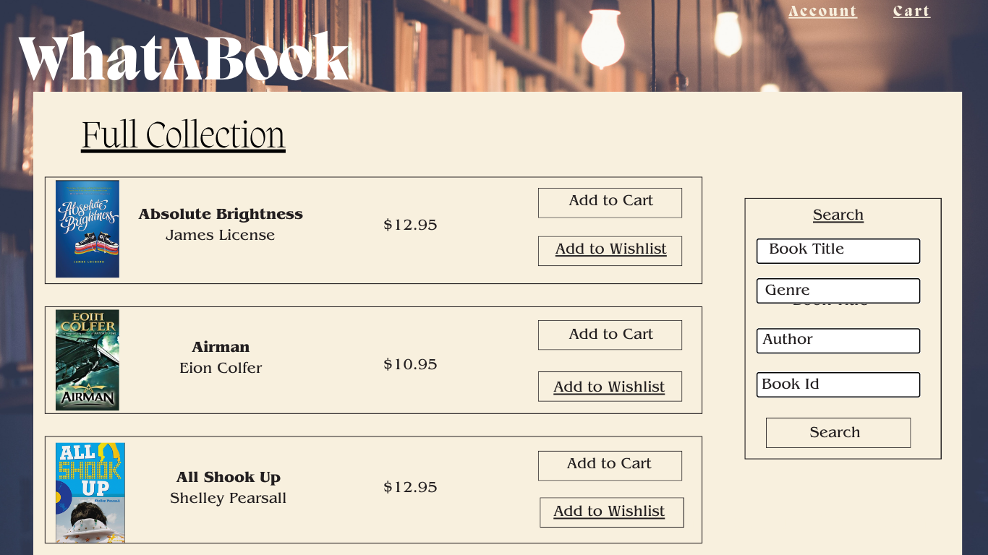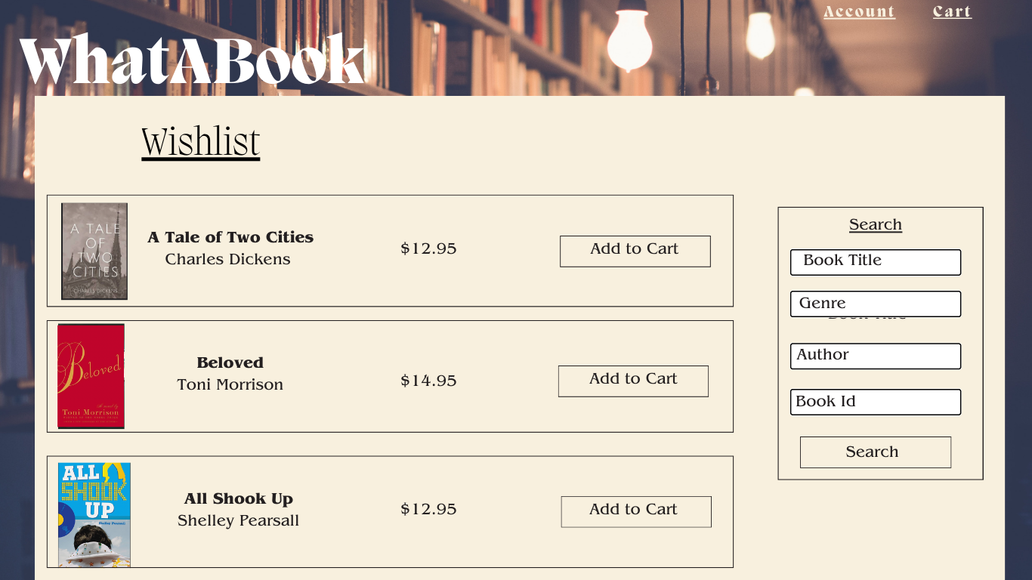

SEARCH RESULTS BY GENRE

SEARCH RESULT BY TITLE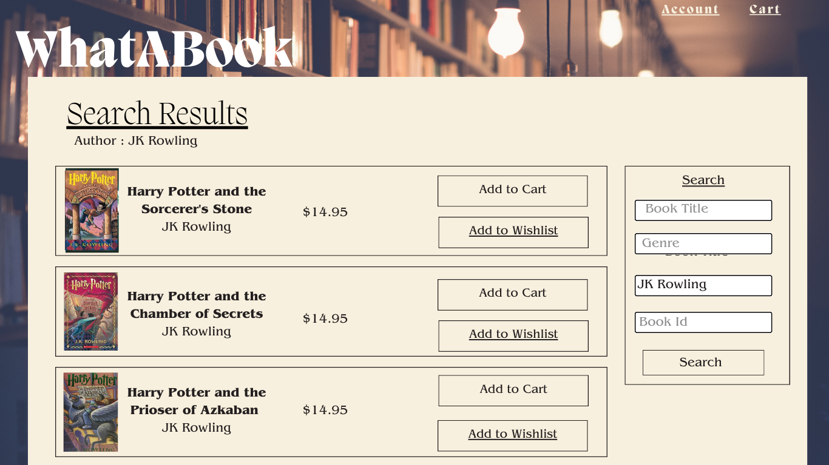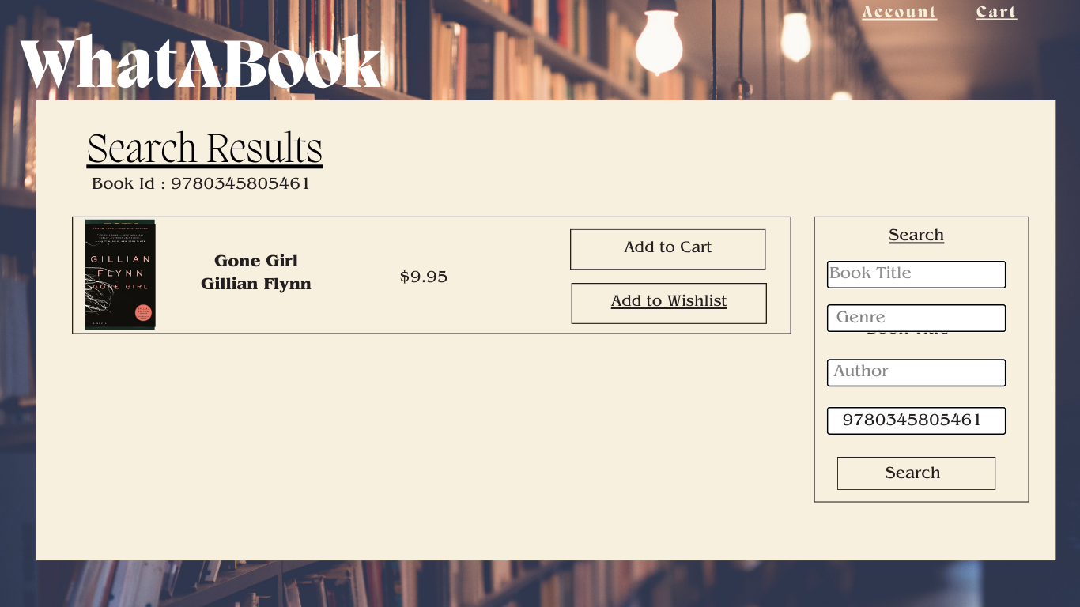

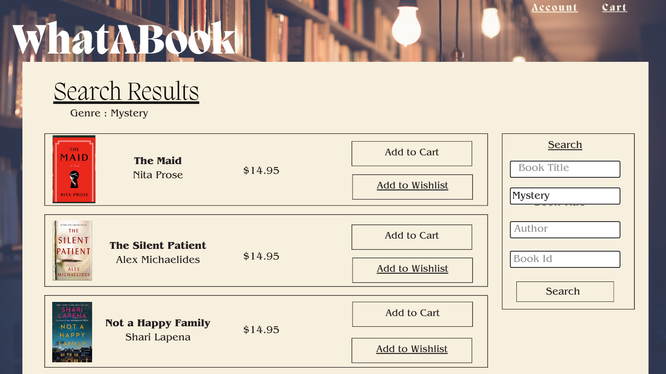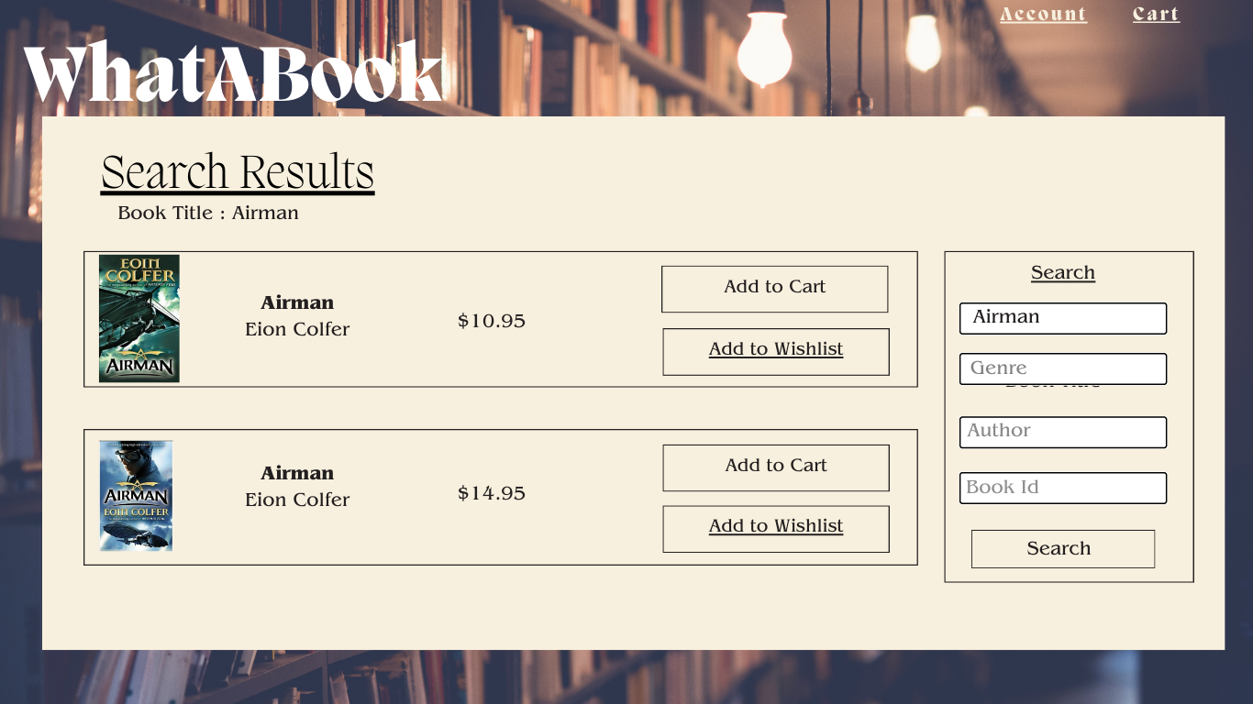3.2: Object Relational Diagram (ORD)

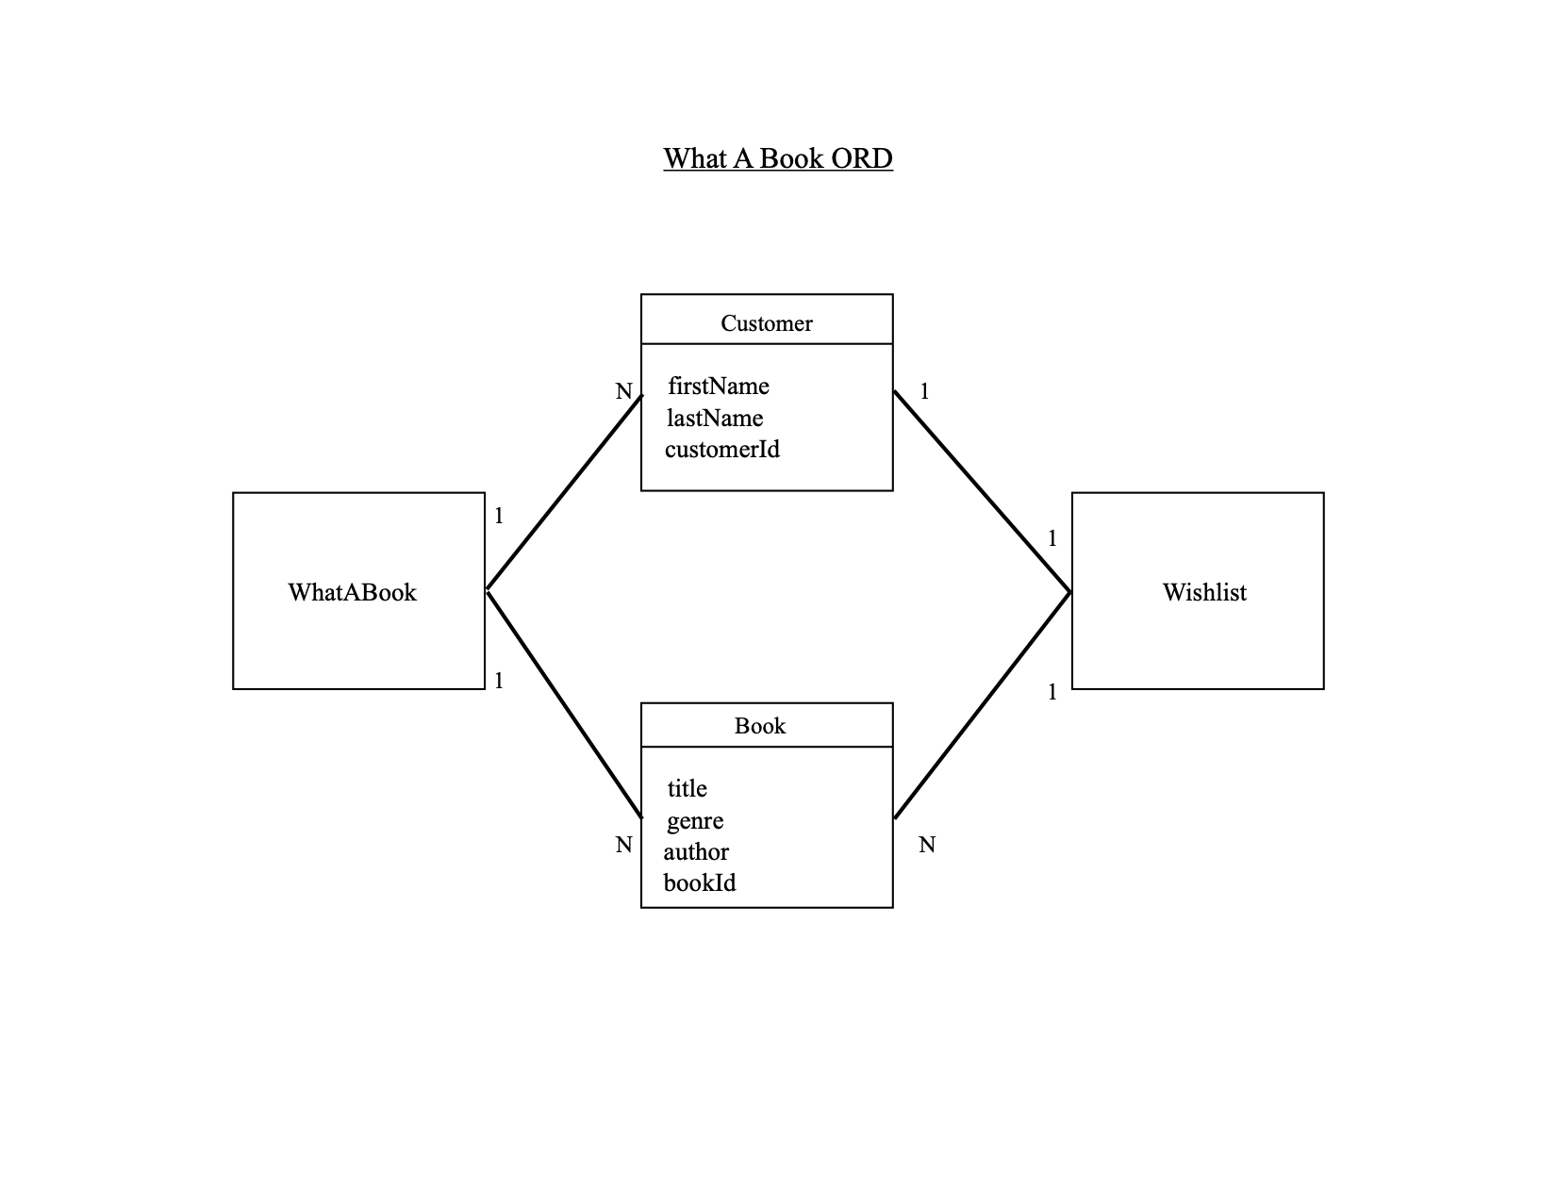

3.3: NoSQL Data Structure

Business Rules

What-A-Book has many CUSTOMERS

a CUSTOMER can have many 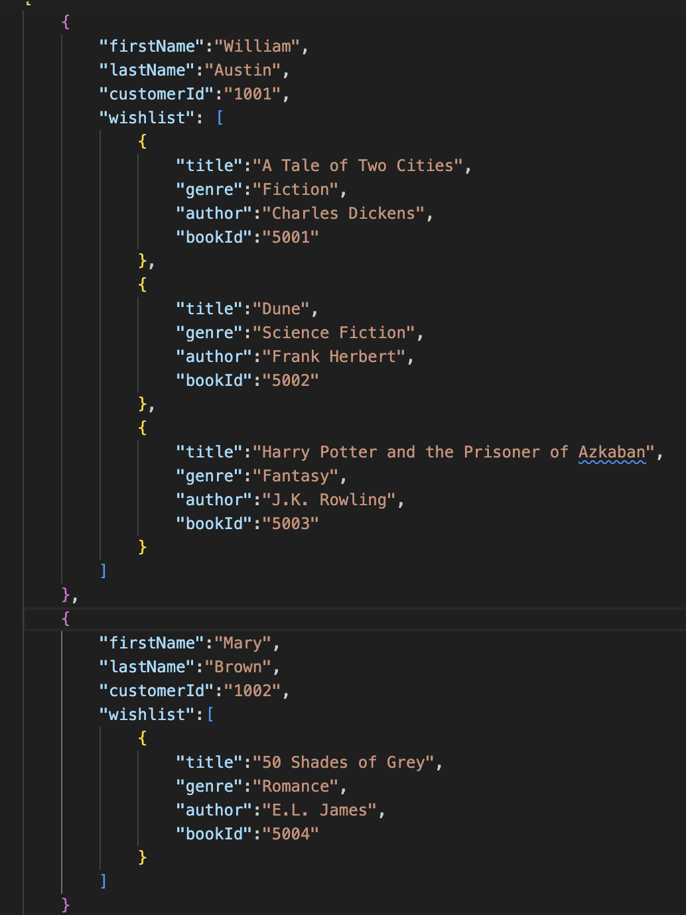WISHLIST BOOK(s)

a CUSTOMER can add many BOOK(s) to their WISHLIST

What-A-Book had many BOOK(s)

